**Experiment- 1.3**

|  |
| --- |
| **Student Name:** Prakhar Deep  **UID:** 21BCS6353  **Branch:** AIML **Section/Group-** 21AIML-7(B)  **Semester:** 3rd **Date of Performance:**10/10/22  **Subject Name:** Operating System **Subject Code:** 21CSH-242 |

1. **Experiment Title: (i)**To write C Programs using the following system calls of UNIX operating system fork, exec, getpid, exit, wait, close, stat, opendir, readdir.

(**ii**)Programs using the I/O system calls of Linux operating system(open, read, write etc).

1. **Requirements:** Oraclevirtual box software, Ubuntu OS.

# 3. Description (commands)-

1. getpid(): It returns the process ID of the calling process.
2. fork(): It is used for creating a new process, which is called child process, which runs concurrently with the process that makes the fork() call.
3. opendir command: open a directory stream corresponding to the directory named by the dirname argument.
4. readdir command: The readdir() function returns a pointer to a dirent structure.
5. exit(): This command is used to break out of a loop.

**4.Algorithm:**

STEP 1: Start the program.

STEP 2: Create struct dirent.

STEP 3: declare the variable buff and pointer dptr.

STEP 4: Get the directory name.

STEP 5: Open the directory.

STEP 6: Read the contents in directory and print it.

STEP 7: Close the directory.

# 5.Snapshots of Above steps-

**Program for system calls of linux os (OPENDIR, READDIR, CLOSEDIR)**

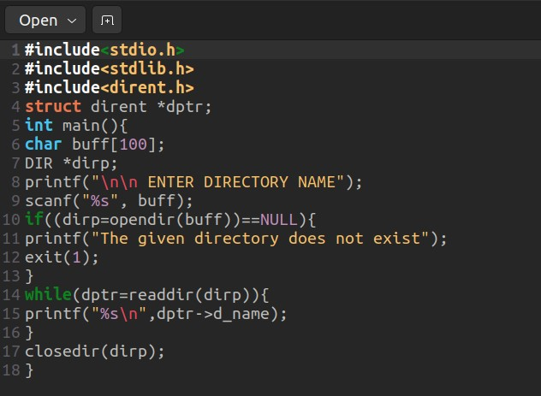

# 6.Output-

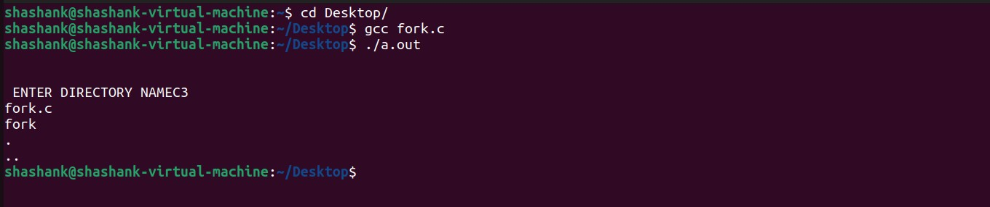

**7.Algorithm:**

STEP 1: Start the program.

STEP 2: Declare the variables pid,pid1,pid2.

STEP 3: Call fork() system call to create process.

STEP 4: If pid==-1, exit.

STEP 5: Ifpid!=-1 , get the process id using getpid().

STEP 6: Print the process id.

STEP 7:Stop the program

# 8.Snapshots of Above steps-

**PROGRAM FOR SYSTEM CALLS OF UNIX OPERATING SYSTEM(fork,**

**getpid, exit)**

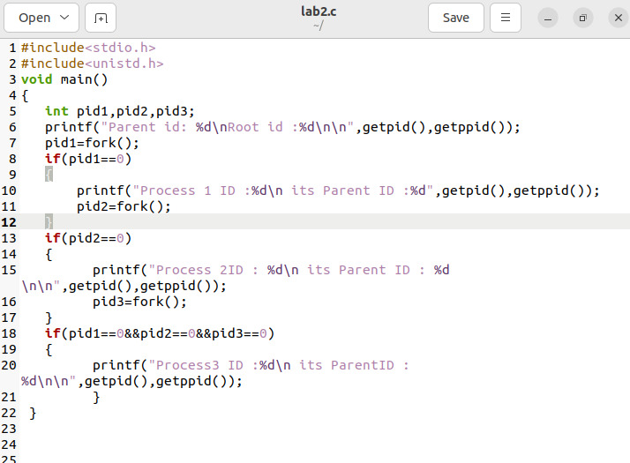

# 9.Output-

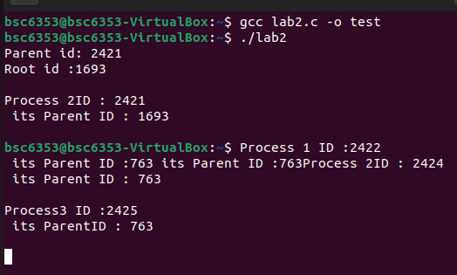

# 5. Result-

Successfully executed UNIX commands program using C language and its compiler.